📄 Technical Flow Document (Employee Desk View)

1. Overview
This document explains the technical flow of the Employee Desk view in the web portal. It covers page-to-page navigation, view product catalogue with price and ‘new arrival,’ order histories, UI structure, and backend interactions.

2. System Roles (For Scope Clarity)
- IT Employee Desk

3. User Flow Diagram (High-Level)
Here you list the main screens in order.
You can make a simple list like this:
- Login
- Customer catalogue
- Customer List
- Chat Page
- Reports
- Settings
- Logout

4. Page-Level Technical Details (Core Part)
4.1 Page Name: Login
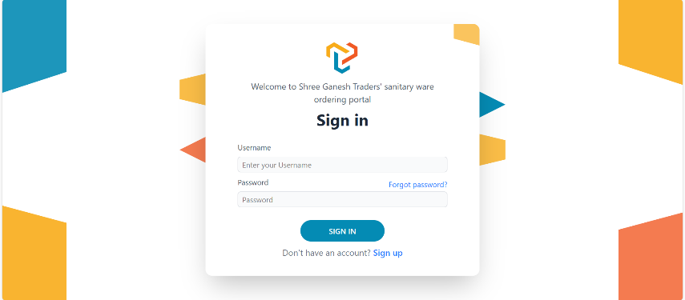
Purpose:
Authenticate employee using username + password.
Figure 1 Login Page
URL:
/
Inputs:
- Username
- Password
Actions:
- Employee enters details → Sign-In
- Backend validates → redirects to final customer’s catalogue page
Success Flow:
Login → Final customer’s catalogue page
Failure Flow:
Login → Error message
Backend APIs Used:
- POST /api/

4.2 Customer’s Product Catalogue
Purpose:
Allow employees to add/modify the product items needed by the final customers.
(Useful for adding new SKUs, updating product info, or managing product visibility.)
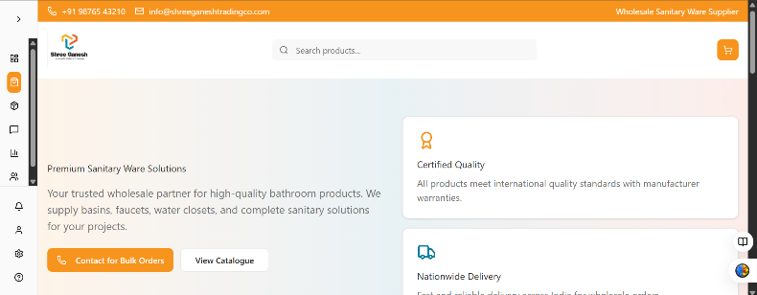
URL:
/employee/catalogue
Figure 2: Final Customer- Description Layer
Contains:
- Description layer:
  - Chat for query
  - View Catalogue Button
Failure Message:
- Catalogue Button Not Working:
  - Button doesn’t have navigation logic
  - Missing useNavigate()
  - Wrong route: /employee/catalogue
  - Backend route not defined

- Chat Query Box Errors:
  - Chat doesn’t respond
    - Backend chatbot down
    - Rate limit
    - Wrong API key
  - Chat doesn’t open at all
- JS error
- WebSocket not connected
- Component not mounted

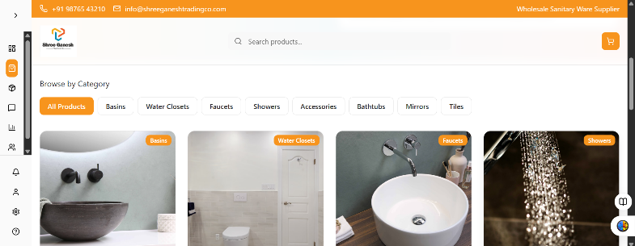
- Product Selection layer:
Figure 3: Final Customer Catalogue Page's Product Selection Layer
  - Category Selection (1st layer)
Failure Messages:
    - Category Not Loading:
      - API /categories fail
      - Slow server
      - Wrong endpoint
      - No categories in database
      - CORS error (Your browser blocks the request because your frontend and backend are running on different domains/ports.)
  - Sub-category Selection (2nd layer)
Failure Messages:
    - Sub-category Not Loading:
      - API /subcategories?category_id= fails
      - Wrong category ID passed
      - Database has no sub-category for that category
      - React state not updated correctly

  - Brand Selection (3rd layer)
Failure Messages:
- Brand List Not Appearing:
  - API /brands?subcategory_id= fails
  - No brand exists for that sub-category
  - Wrong sub-category ID passed

[NOTE: It appears one-by-one. Further, you can select more products.]
Failure Messages:
- Selecting Multiple Products Creates Conflicts:
  - State doesn’t reset
  - Old selection overlaps with new data
  - API fetch re-renders dropdown incorrectly

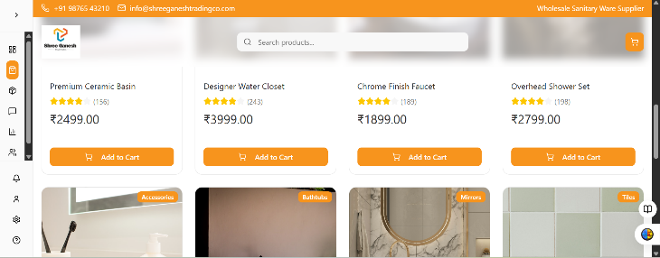
- Product Card Field Details:
Figure 4 Final Customer Catalogue Page’s Product Cart Details layer
  - Product Name
  - Brand
  - Rating (Not necessary)
  - Category
  - Price
  - Product Image
  - Stock (Available/ Not Available)
Actions:
- Product cards
- Add to cart button, gets added to the cart
- Product details after clicking that card
Navigation:
Clicking the product’s image → Getting the product’s detail
Failure Messages and Errors:
- Product Image Loading Errors:
  - Image missing
  - Wrong path
  - Server down
  - File deleted or corrupted

- Stock Issues:
  - Stock=0
  - Stock not updated
  - Employee forgot to mark availability
  - API fails to load stock

- Add to Cart Errors:
  - Cart API down
  - Product inactive
  - Price not available
  - Variation missing
  - User not logged in (if required)

- Product Details Page Errors (On Click):
  - Product ID invalid
  - Product deleted
  - Product hidden by employee
  - API returns 404

- Data Fetch/ API Errors:
  - Slow internet
  - Server overload
  - API timeout
  - Incorrect API route

Backend APIs:
- GET /api/catalogue/products

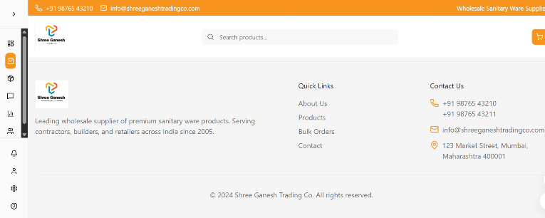
- Product Catalogue Base layer:
  - Description with Logo
  - Quick Links:
    - About Us
    - Catalogue Page
    - Chat Window
    - Customer Details
  - Contact details:
    - Phone Numbers
    - Professional Email
    - Address

4.2.1 Page Name: Customer Cart & Purchase Mapping
Purpose
Allow employees to add selected products to a temporary cart, choose the customer who purchased the items, and then submit the purchase entry to the backend for processing, billing, and rewards calculation.
This feature is used when:
- A final customer walks into the shop
- Employee selects multiple items from the catalogue
- Employee assigns the purchase to that specific customer

URL
/employee/catalogue/cart

Contains
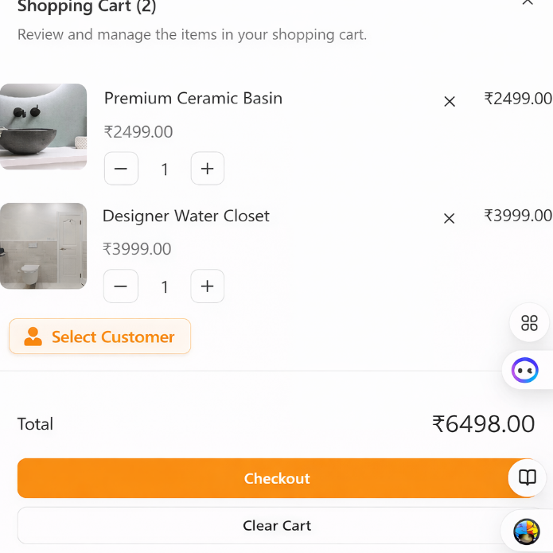
1. Cart UI (Front-End View)
The cart UI resembles the screenshot provided and includes:
Cart Header
- Title: “Shopping Cart (X items)”
- Close button (X)
- Short description:
“Review and manage the items in your shopping cart.”
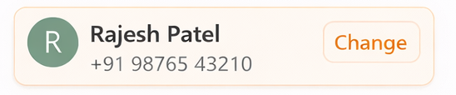
Cart Items Section (Repeated for each product)
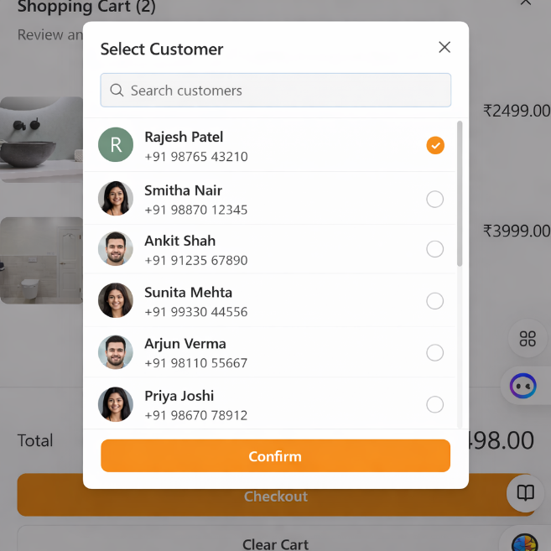
Each product card contains:
a. Product Image
- Shows the selected product’s photo
- Clicking opens product details
b. Product Title
- Example: “Premium Ceramic Basin”
c. Product Price
- Example: “₹2499.00”
d. Quantity Selector
- “–” (Decrease quantity)
- Number input: Default = 1
- “+” (Increase quantity)
e. Remove Product
- “X” delete icon
- Removes the product from cart

Customer Selection Before Checkout
Before allowing checkout, employee MUST choose:
Select Customer (Dropdown)
- Searchable list
- Contains:
  - Customer Name
  - Phone Number
  - Reward Points
If no customer is selected → checkout blocked.
Bottom Section (Cart Summary)
- Total Price: Auto-calculated
- Checkout Button
- Clear Cart Button

Actions
1. Add to Cart
- Adds the selected product into the cart
- If product already exists → increase quantity (instead of duplicate item)
2. Update Quantity
- “+” adds 1
- “–” removes 1
- If quantity becomes 0 → remove product
3. Remove Product
4. Clear Cart
5. Select Customer
- Mandatory before submitting purchase
6. Checkout
Employee submits:
- Selected Customer ID
- Items + Quantity
- Total price
- Timestamp

Backend Logic
Checkout Payload (When employee confirms purchase)
POST /api/purchases/create/
{
"customer_id": 101,
"items": [
{
"product_id": 42,
"quantity": 1,
"price": 2499
},
{
"product_id": 55,
"quantity": 1,
"price": 3999
}
],
"total": 6498,
"employee_id": 7
}

Backend Tasks After Checkout
1. Save Purchase Record
Store a new purchase entry.
2. Update Purchase Frequency
customer.purchase_frequency += 1
3. Update Total Purchase Amount
customer.total_purchase += cart_total
4. Add Reward Points
Example Rule:
reward_points = cart_total / 100
(You can customize.)
5. Update Stock
For each item:
product.stock -= quantity

6. Create Order History
Each item logged individually under customer’s purchase history.
7. Notify Customer (Optional)
- SMS
- WhatsApp
- Email

Backend APIs
GET /api/customers
Load customer list for selection.
GET /api/catalogue/products
Load product details.
POST /api/purchases/create/
Submit purchase.
PUT /api/products/update-stock
Update inventory.

Failure Messages & Errors
1. Customer Selection Errors
UI-Level Errors
Displayed immediately to the employee.
• “Please select a customer before checkout.”
Cause: Checkout clicked without customer selection.
• “Selected customer is required.”
Cause: Customer selection cleared unintentionally.

API-Level Errors
Returned from backend.
• “Customer not found.”
Cause:
- Invalid customer_id
- Customer deleted
• “Customer is inactive or blocked.”
Cause:
- Customer account disabled
• “Failed to load customer list.”
Cause:
- /api/customers timeout
- Network issue

2. Cart Validation Errors
UI-Level Errors
• “Cart is empty.”
Cause: Checkout attempted with zero items.
• “Quantity must be at least 1.”
Cause: Manual quantity input invalid.

API-Level Errors
• “Unable to add product to cart.”
Cause:
- Product unavailable
- Product disabled
• “Failed to update quantity.”
Cause:
- Concurrent update
- API timeout
• “Product no longer available.”
Cause:
- Product removed from catalogue

3. Stock & Inventory Errors
Pre-Checkout Validation
• “Requested quantity not available.”
Cause:
- Stock less than requested quantity
• “Stock changed. Please review cart.”
Cause:
- Stock updated by another employee

Post-Checkout Errors
• “Stock update failed.”
Cause:
- Database lock
- Inventory service down

4. Checkout & Purchase Errors
Payload Validation Errors
• “Invalid checkout data.”
Cause:
- Missing fields
- Wrong data type
• “Payment calculation mismatch.”
Cause:
- Total mismatch between frontend and backend

Purchase Processing Errors
• “Failed to create purchase.”
Cause:
- Database error
- Permission issue
• “Unable to update customer purchase data.”
Cause:
- Customer table lock
- Partial transaction failure
• “Reward calculation failed.”
Cause:
- Rule misconfiguration

5. Product Image & Asset Errors
UI-Level
• “Image not available.”
Fallback behavior:
- Show placeholder image

System-Level
• “Failed to load product image.”
Cause:
- CDN / Cloud storage unreachable

6. Network & System Errors (Global)
• “Server is currently unavailable.”
Cause:
- Backend down
• “Internet connection lost.”
Cause:
- Client offline
• “Unexpected error occurred. Please try again.”
Cause:
- Unknown exception

7. Error Handling Rules (Very Important)
Add this small section — it makes your doc professional:
UI Rules
- Errors shown as:
  - Toast for non-blocking errors
  - Modal for blocking errors
- Error messages auto-dismiss after 3–5 seconds

4.3 Chat Window (with Order Accept/Reject System)
Purpose
To allow employees to manage customer conversations and handle order decisions—accept, reject, ask for more details, or forward the order to the owner for higher approval—directly within the chat interface.
URL
/employee/messages

Contains (UI Components)
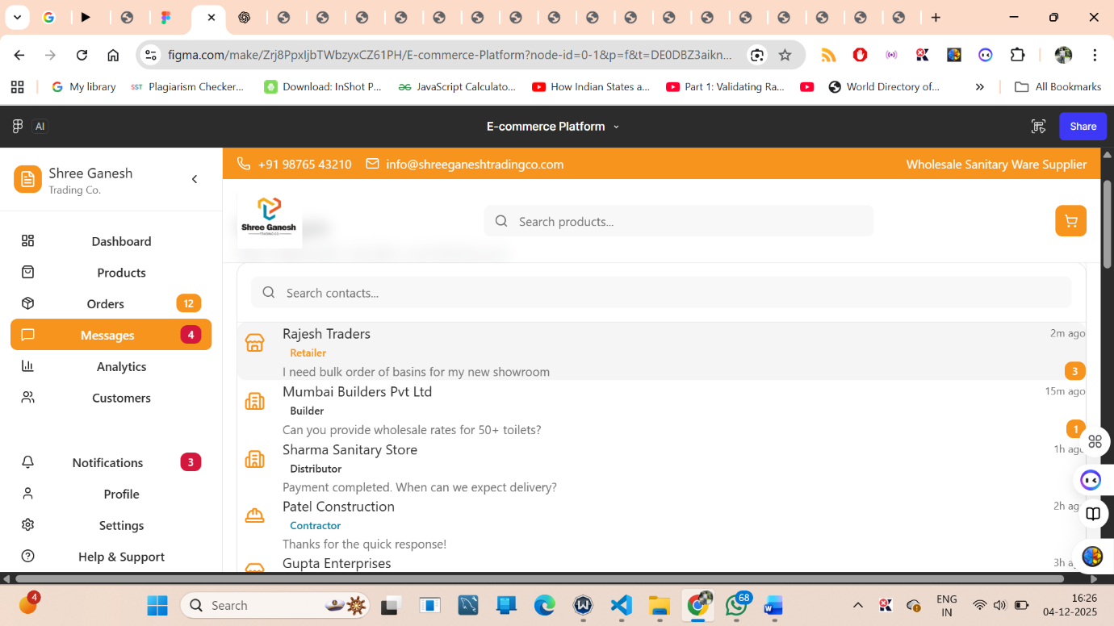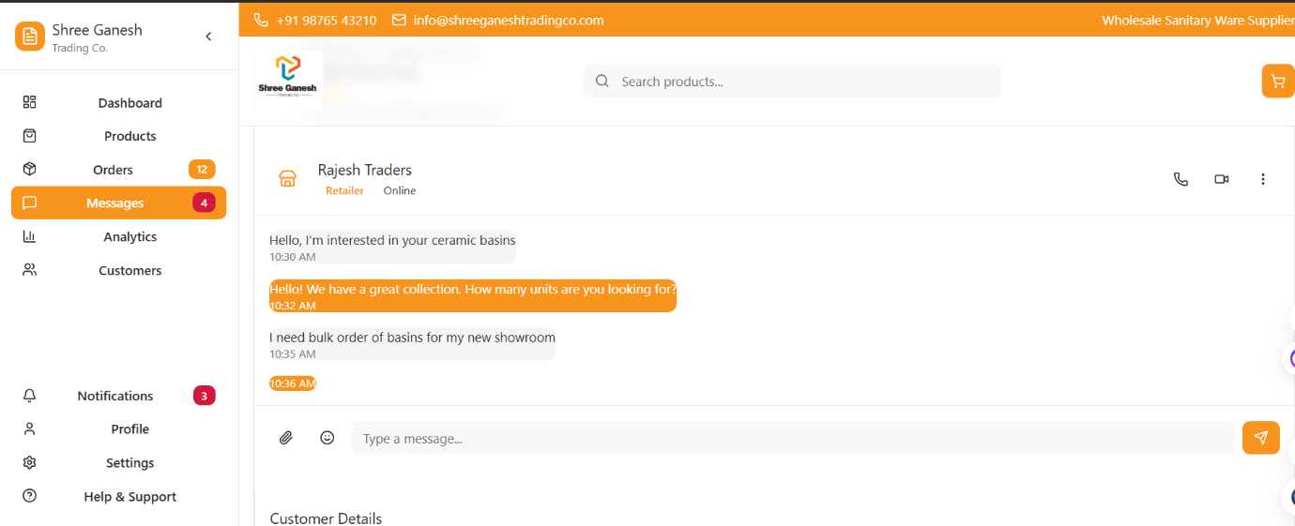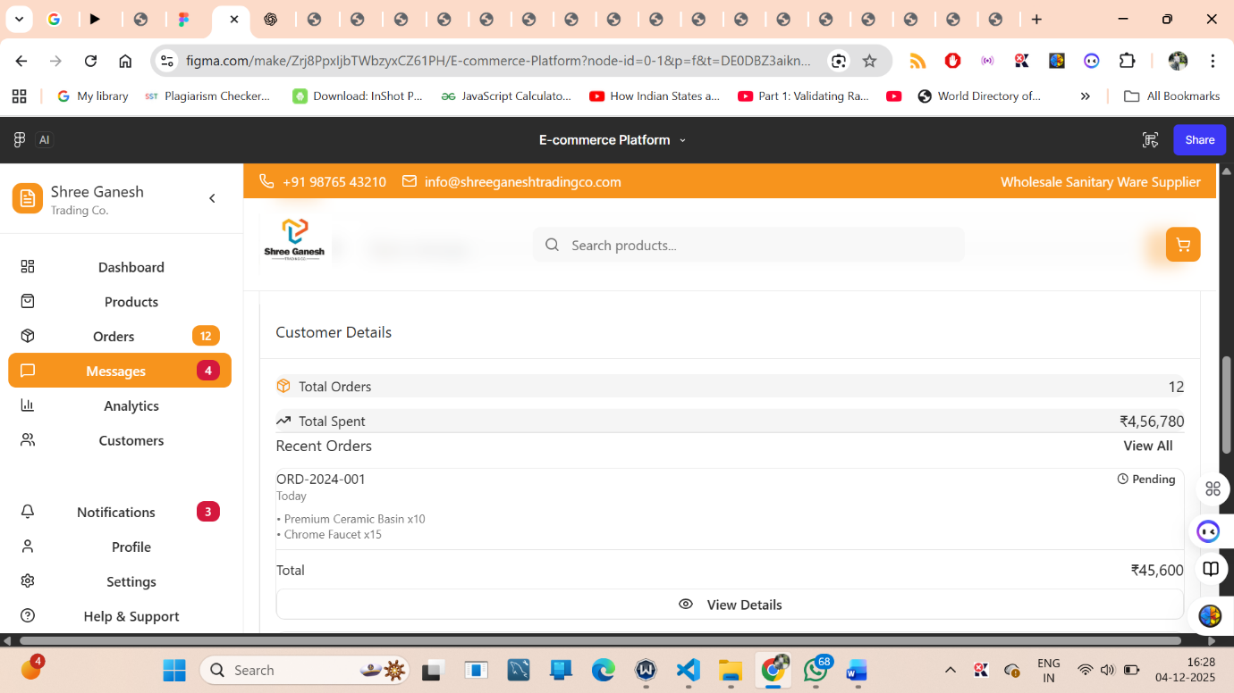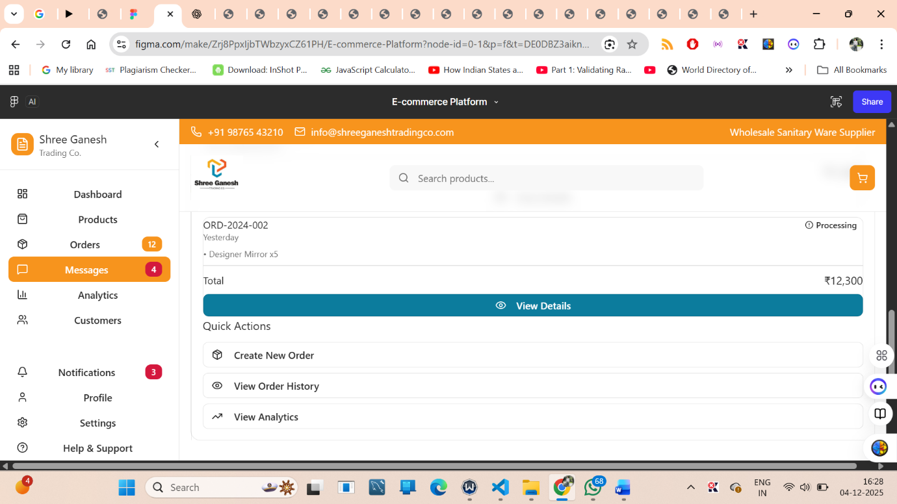
1. Conversation List (Left Panel)
Displays all customers who messaged.
Visible fields:
- Customer Name / Company Name
- Customer Type (Retailer, Distributor, Contractor, Builder, etc.)
- Last message preview
- Rewards
- Timestamp
- Unread message count
- Customer icon

2. Chat Window (Right Panel)
This is the main messaging area.
Header Section
- Customer Name
- Customer Type
- Customer Contact (optional)
- “View Order History” link
- “Quick Actions” menu
Chat History
Shows:
- Customer messages
- Employee replies
- Timestamps
- Delivery/read indicators (optional)
Order Request Cards
When a customer mentions a product need (quantity, brand, price inquiry, etc.), the system displays:
Order Request
Product: CPVC Elbow 1” (×20)
Requested: 5 minutes ago
View Details Button:
It shows the detailed order requested.
Example Card:
Order Request
Product: Premium Basin (x10)
Requested: 5 minutes ago
Buttons:
- Accept Order (🟢)
- Reject Order (🔴)
- Forward Order to owner (⏩)
- Ask for More Details (⚪ optional)

Actions Supported
✔ 1. Send and receive messages
Normal chat operations.
✔ 2. Accept Order
Employee clicks Accept Order → modal appears.
Fields required:
- Confirm Product(s)
- Confirm Quantity
- Confirm Price
- Confirm Delivery Date
- Optional Note
On Confirm:
- Order gets created
- Confirmation is sent to customer automatically
- Redirect (optional): /employee/orders/{order_id}
✔ 3. Reject Order
Employee clicks Reject Order → modal appears and sends the notification to the owner.
Required: Rejection Reason (Dropdown)
- Out of Stock
- Quantity Not Available
- Delivery Not Possible
- Pricing Not Approved
- Customer Credit Issue
- Duplicate Order
- Other (text input appears)
Optional: Note
Mandatory Validation:
If reason is missing → block submission
System Message:
- “Please select a rejection reason to continue.”
After submission:
- Reason is logged
- Customer receives rejection message
- Order request is closed
✔ 4. Ask for More Details
Sends an automated message like:
“Please share the size/brand/quantity details.”
✔ 5. Forward Order to Owner (NEW)
Employee clicks Forward to Owner → modal opens.
Purpose:
For cases where employee cannot decide (pricing conflict, credit issue, bulk order, VIP customer).
Fields:
- Optional Note to Owner (ex: “Requires special discount approval”)
- Include order details automatically
On Confirm:
- Order request is sent to owner
- Owner receives notification
- Employee sees:
“Order forwarded to owner for approval.”
System Status Saved As:
Forwarded to Owner
Customer Message (optional):
“Your request has been forwarded for approval. We will update you shortly.”

✔ 6. View Order History
Opens previous orders for that customer.

Backend APIs Used
Fetch Conversations
GET /api/messages/conversations
Fetch Chat History
GET /api/messages/{conversation_id}
Send Message
POST /api/messages/send
Accept Order
POST /api/order/accept
{
"conversation_id": 12,
"customer_id": 101,
"products": [{“id": 7, "qty": 10}],
"price_confirmed": 450,
"delivery_date": "2025-02-12",
"note": "Deliver by evening"
}
Reject Order
POST /api/order/reject
{
"conversation_id": 12,
"customer_id": 101,
"reason": "Out of stock",
"note": "Available next week"
}
Mark As Read
POST /api/messages/{conversation_id}/read

Navigation Flow
- Messages → Select Customer → Chat Window
- Chat Window → Accept/Reject Order
- If accepted → Redirects to /employee/orders/{order_id}
- If rejected → Stays in chat view
- Employee can go to:
  - Orders
  - Customer Profile
  - Settings

Failure Messages and Errors
1. Message-Related Errors
- “Message failed to send.”
- “Unable to load chat history.”
- “Failed to retrieve messages.”
- “Attachment upload failed.”
- “Unsupported file type.”
2. Conversation Errors
  - “Conversation not found.”
  - “Unable to load conversation.”
  - “Customer no longer exists.”
  - “Failed to update unread messages.”

3. Accept Order Errors
  - “Product is out of stock.”
  - “Quantity unavailable.”
  - “Invalid product details.”
  - “Price confirmation required.”
  - “Delivery date missing.”
  - “Failed to accept order. Try again.”
  - “Order creation failed due to server error.”

4. Reject Order Errors
  - “Please select a rejection reason to continue.”
  - “Reason is required to reject an order.”
  - “Unable to reject order. Try again later.”
  - “Failed to send rejection message.”

5. Forward Order Errors
  - “Unable to forward order. Try again.”
  - “Owner not reachable.”
  - “Forwarding failed due to server issue.”
  - “Order cannot be forwarded at this stage.”

- Permission Errors
  - “You do not have permission to accept orders.”
  - “You do not have permission to reject orders.”
  - “You do not have permission to forward orders.”
  - “Owner approval required for this action.”

- Real-Time Sync Errors
  - “Real-time connection lost.”
  - “Failed to sync new messages.”
  - “Unable to refresh chat.”

8. Customer-Side Errors
- “Customer is offline.”
- “Customer session expired.”

9. General System Errors
- “Something went wrong.”
- “Server temporarily unavailable.”
- “Network connection lost.”

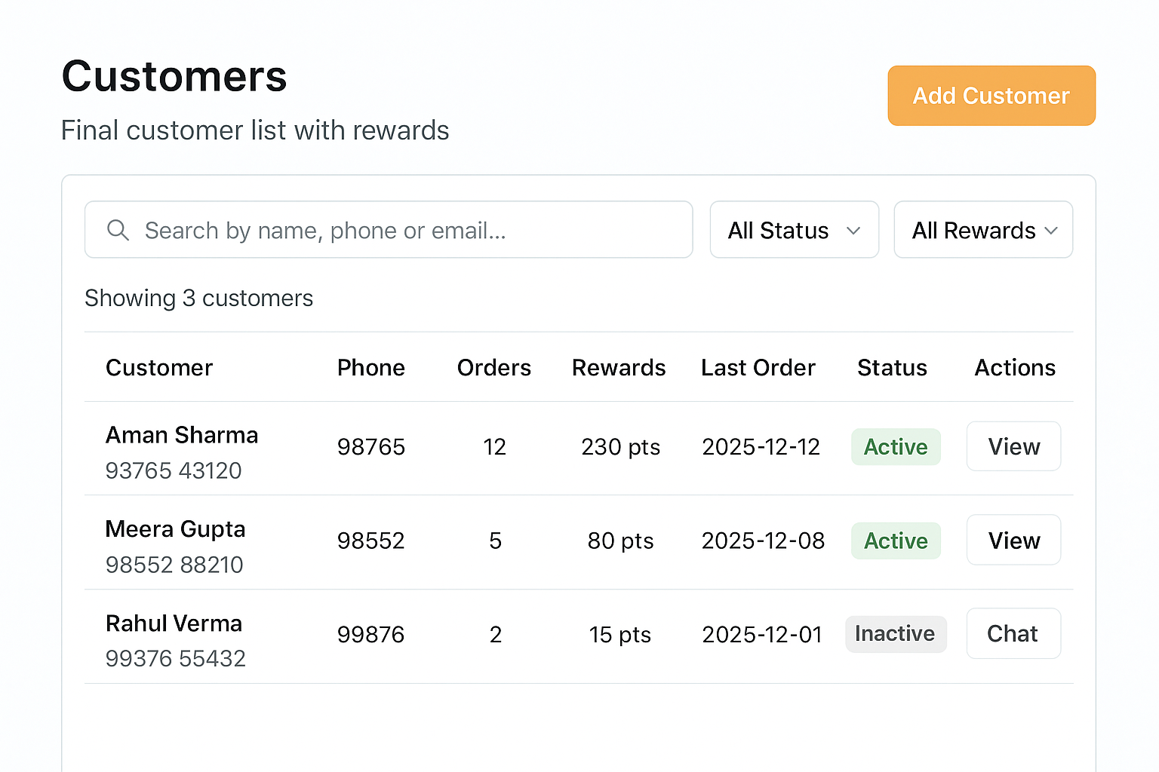
4.4 Customer List
Purpose
Display a list of all final customers and allow employees to view detailed customer analytics such as major items bought, purchase frequency, rewards, and total purchase amount.
URL
/employee/customers
Contains
The Customer List table includes the following columns:
Table Columns
- Name – Customer’s full name
- Phone – Contact number
- Total Purchase – Total money spent by the customer
- Customer Purchase Frequency – Number of times the customer bought items (total orders)
- Rewards – Reward points accumulated
- Last Order – Date of most recent purchase
- Status – Active / Inactive
- Actions
  - View (opens customer detail page)
  - Edit (optional)
  - Message/Chat (optional)
Filter & Search Options
- Search by name, phone number, or email
- Filter by:
  - Rewards range
  - High–Low purchases
  - Frequency (repeat customers vs. one-time buyers)
  - Status
  - Last order date
Navigation
Customers → Customer List → Customer Detail
Backend APIs
- GET /api/customers
  - Returns full list of customers
- GET /api/customers/{id}
  - Returns detailed information for a specific customer

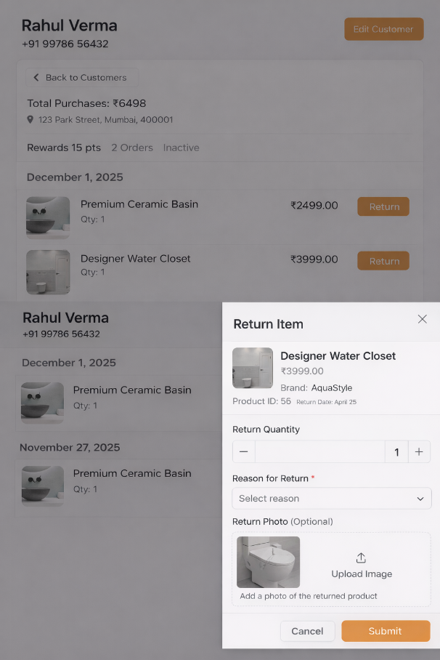
4.4.1 Customer Detail View
This section loads when the employee clicks View on any customer row.
Purpose
Show detailed analytics for an individual customer to help employees understand buying behavior, rewards, and important patterns.
URL
/employee/customers/{id}
Contains
Customer Personal Information
- Name
- Phone
- Email (optional)
- Address (optional)
Purchase Summary
- Total Purchase (Total revenue generated by customer)
- Customer Purchase Frequency
(How many times the customer has bought from the store)
- Last Order Date
- Average Order Value (optional)
- Biggest Order (optional)
Rewards Summary
- Reward points
- Tier (Silver / Gold / Platinum) – optional
- Expiring points – optional
Major Items Bought
A list showing frequently purchased or high-value items:
Item Name | Category | Total Quantity | Total Spent
Example:
- “Chrome Faucet” – Bought 12 times
- “Wall-Hung Toilet Seat” – Bought 4 times
- “Ceramic Basin” – Bought 6 times
Order History Preview
Show the last 3–5 orders with:
- Order ID
- Date
- Items
- Status
- Total Amount
- Button: View Full Order
Customer Notes (Optional)
Employees can add internal notes such as:
- “Prefers cash on delivery”
- “Bulk buyer for construction business”
Actions
- Edit Customer
- Chat / Send Message
- View Full Order History
- View Rewards History
- Download Customer Report (PDF) – optional
Failure Messages & Errors (Customer List & Customer Detail)
- Loading Errors
- “Unable to load customer list.”
- “Customer details could not be fetched.”
- “Server not responding. Please try again.”
- Empty State
- “No customers found.”
- “No purchase data available for this customer.”
- Search/Filter Issues
- “No customer matches your search.”
- “No customers found for selected filters.”
- Reward Errors
- “Unable to fetch reward points.”
- “Failed to update customer reward status.”
- Detail Page Errors
- “Unable to load customer’s order history.”
- “Item purchase data missing.”
- “Customer not found.”

4.5 Page Name: Settings
Purpose
Provide employees with control over personal preferences and system configurations, including notification settings, order alerts, password changes, UI appearance, and language preferences.
This page helps employees personalize how the system behaves for them.

URL
/employee/settings

Contains
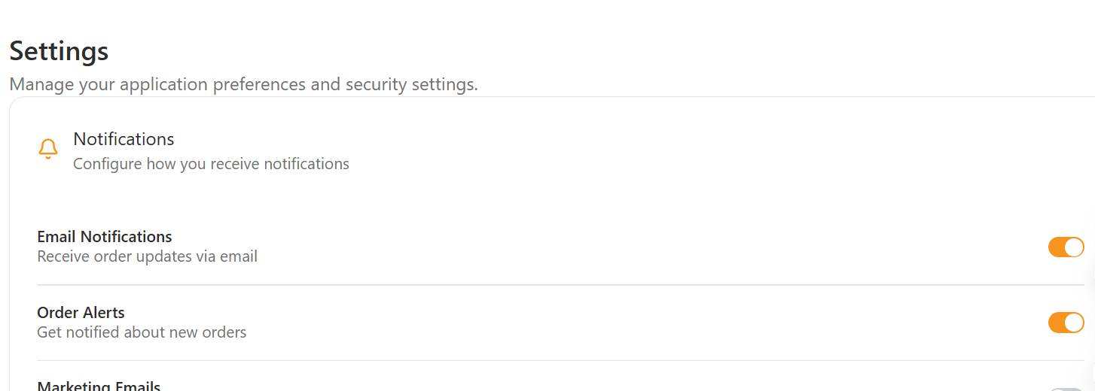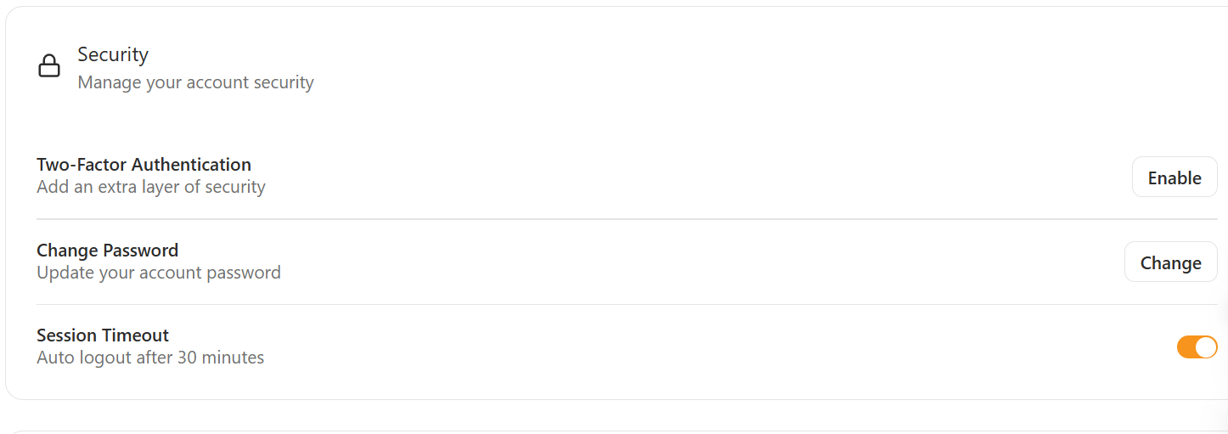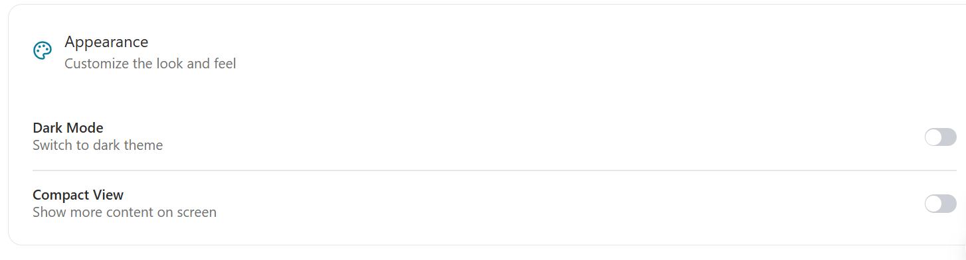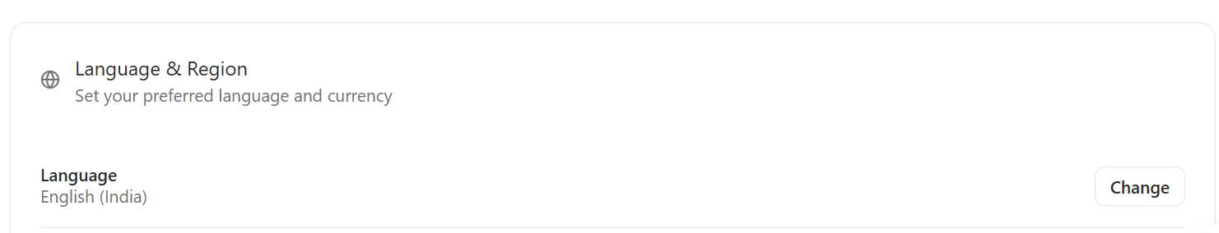
1. Notification Settings
- Toggle New Order Alerts
- Toggle Low Stock Alerts
- Toggle Customer Messages Alerts
- Toggle System Notifications
2. Order Alerts Configuration
- Set alert sound ON/OFF
- Set vibration mode (for mobile)
- Priority level setting:
  - High priority = Always show popup
  - Medium priority = Show in notifications panel
  - Low priority = Silent
3. Account Settings
- Change Password
  - Old password
  - New password
  - Confirm new password
- Logout button
4. Display Settings
- Dark Mode Toggle
(Light / Dark / Auto System Mode)
5. Language
- Language selection dropdown
  - English
  - Hindi
  - Punjabi
- Number format
6. Other Optional Controls
- Clear cache / Reset saved filters
- Manage connected devices
- Allow/disallow email alerts
Actions
- Save Settings
- Reset to Default
- Test Notification Sound

Backend APIs
GET /api/employee/settings
Used to fetch the existing settings for the logged-in employee.

PATCH / PUT /api/employee/settings/update
Used to update:
- Notification preferences
- Display mode
- Language settings
- Alert configurations

POST /api/employee/change-password
Used to update password securely.

Failure Messages and Errors (Settings Page)
This section lists all possible errors that employees might face.
1. Loading Errors
- “Unable to load settings. Please try again.”
- “Network issue. Failed to fetch settings.”
Causes:
- Backend unavailable
- Network disconnection
- Invalid authentication token
2. Save / Update Errors
- “Failed to save settings.”
- “Unable to update notification preferences.”
- “You do not have permission to change this setting.”
- “An unexpected error occurred while updating your settings.”
Causes:
- API error
- Incorrect payload format
- Employee privilege issues
- Server timeout
3. Change Password Errors
- “Old password is incorrect.”
- “New password must be at least 8 characters.”
- “Passwords do not match.”
- “Failed to change password. Try again later.”
- “This password was used recently. Choose a different one.”
Causes:
- Wrong old password
- Weak new password
- Server validation failure
4. Notification Settings Errors
- “Failed to update notification preferences.”
- “Notification sound file missing.”
- “Push notifications are disabled by the browser.”
Causes:
- Browser blocking notifications
- Incorrect alert configuration
- Missing audio file
5. Dark Mode / Display Errors
- “Failed to apply dark mode.”
- “Display settings could not be saved.”
Causes:
- Browser storage issue
- UI rendering conflict
6. Language Selection Errors
- “Selected language not available.”
- “Translation files failed to load.”
Causes:
- Missing translation JSON
- Server not sending language assets
7. Reset to Default Errors
- “Unable to reset settings.”
- “Server failed to apply default configuration.”
8. Authentication Errors
- “Session expired. Please log in again.”
- “Unauthorized access to settings.”

6. Error Handling Rules
- Session timeout → redirect to login
- Invalid ID → show “Record not found”
- Missing fields → show small alert

7. Security Notes
- JWT token required for all API calls
- Role-based access
- No employee should see other sites unless allowed

8. Future Scope
Add features later such as:
- Chatbot
- Notifications
- Multi-branch linking

